Linecrew Bulletin

[Click here to enter a date]

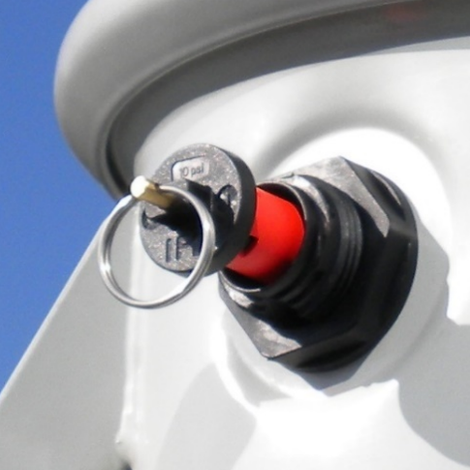
Overview
This bulletin will review the following:
- Two functions of the IFD Sensor
- IFD Shipping Lock
- Installing IFD equipped transformers

Two functions of the IFD Sensor

Internal fault detection
Activated
- The IFD Sensor is a mechanical device that detects rapid pressure rises associated with low impedance faults
- When troubleshooting transformer outages, an activated IFD Sensor indicates that the transformer has faulted internally and must be replaced. No additional troubleshooting is required

Pressure relief
- The IFD Sensor includes a PRV designed to automatically relieve tank pressures that develop from transformer load or ambient temperatures
- The PRV functions with or without the IFD Shipping Lock installed

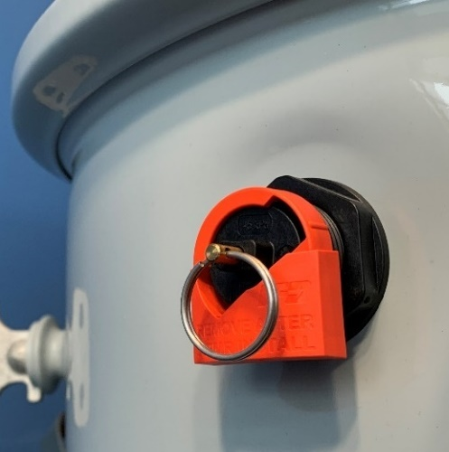
IFD Shipping Lock
Not Activated
The IFD Shipping Lock prevents the IFD Sensor from activating while:
- Transporting the transformer
- Installing and preparing the transformer for field service
The Shipping Lock must remain installed until just prior to transformer energization.
If an un-faulted transformer is removed from service, a Shipping Lock must be re-installed.
IFD Shipping Lock

Installing IFD equipped transformers
When installing IFD equipped transformers, the Shipping Lock must remain installed while:
- Moving or lifting the transformer
- Making cable connections
- Venting the PRV (if required)
- Changing or installing a bayonet fuse (if required)
Removing the Shipping Lock is the last step before transformer energization.
If the IFD Shipping Lock is removed early and the IFD Sensor activates prior to transformer energization, please contact Click or tap here to enter text. for support.
Installing IFD Equipped Pole-mounted Transformers

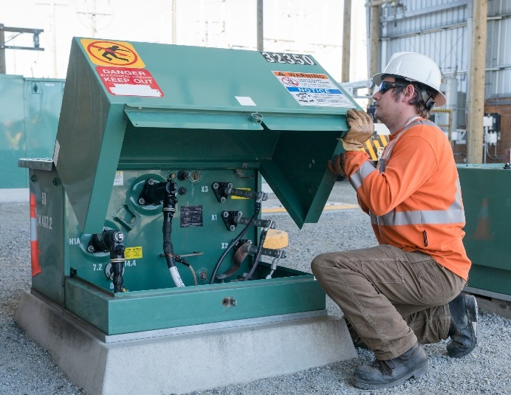
Key points
- When troubleshooting a transformer outage, an activated IFD Sensor indicates that a field energized transformer has faulted internally and must be replaced. No further troubleshooting is required.

- When installing IFD equipped transformers, the Shipping Lock should only be removed immediately prior to transformer energization. It should be re-installed before moving an un-faulted transformer.

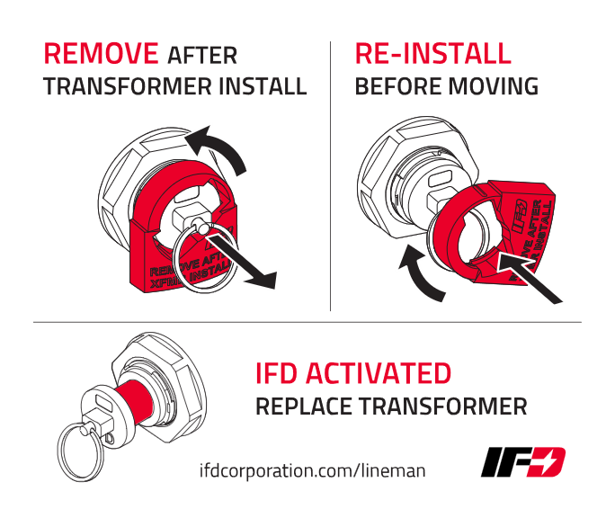
- Do not re-energize or energize a transformer with an activated IFD Sensor. If the IFD Sensor activates prior to transformer energization, contact Click or tap here to enter text. for support.
Installing IFD Equipped Pad-mounted Transformers

Resources
- An IFD Sensor Tailgate Training Video can be found at:
https://ifdtech.com/resources-for-utilities/
- Each transformer includes an IFD Decal which reviews the function of the IFD Sensor and the Shipping Lock
IFD Decal

